|  |  |
| --- | --- |
|  | **YEAR 12ATARPHYSICS**  ***Unit 4***  **PRACTICAL TEST2017 *5.0%***  **NAME: ………………………………………………….**  Others in the Group: …………….……………………………..  Data: See Data Sheet  Approx. marks shown.  ***(35 marks)*** |

When calculating numerical answers, show your working or reasoning clearly. Give final answers to **CORRECT** significant figures and include appropriate units where applicable.

**BACKGROUND:**

The Planck constant plays a central role in understanding the properties of matter and energy. It is a cornerstone of the theory of quantum mechanics. Named after German physicist Max Karl Planck (1858-1947), the Planck constant tells us how the energy of individual photons relates to the wavelength of their radiation:

$$E = hc/λ$$

where *E* is the energy of a single photon (in joules),

*h* is the Planck constant,

*c* is the speed of light in a vacuum, and

*λ* is the wavelength of the radiation.

**How light emitting diodes work**

Light emitting diodes or LEDs are produced by the junction of two 'doped' semiconductor materials, one of which has an excess of electrons (n-type) and the other a lack of electrons (p-type). When an electrical current passes through this junction, energy is released in the form of photons. The energy of each photon determines the colour of the light emitted. The amount of energy can be tailored by modifying the chemical composition of the semiconductor materials. LEDs can emit light in specific colours, such as red and green in the visible region of the electromagnetic spectrum, or beyond into the ultraviolet and infra-red regions.

The wavelength determines the colour of the light emitted. For example, green-emitting LEDs typically produce light with a wavelength of around 567 nanometres. Each colour of LED has a different threshold voltage at which electrons start being produced. Measuring this voltage, together with known values for the emission wavelengths, provides a way to determine a value for the Planck constant.

**Part A Collecting the Data:**

**AIM:** To determine a value for the Planck constant.

**APPARATUS:** Six LEDs emitting different colours - red, yellow, green, blue, infrared and ultraviolet. (The LEDs have a clear, colourless casing surrounding the LED, so that the colour is determined by the device itself, not from the coloured casing.)

DC power supply set to 4 V.

100 Ω resistor

1.0 kΩ potentiometer (Variable resistor) set up with 3 leads, yellow, white and green

A voltmeter set to 20V

an ammeter set to 20 mA

additional leads

**METHOD:**

1. Set up the circuit as shown in the diagram. Do NOT attach the LED.

Top view of potentiometer.

a is zero

a

c

b

a

0 V

LED

V

A

100 Ω

+4 V

c

b

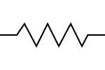



1.00 kΩ

DO NOT turn the power supply on until the circuit has been marked by the Teacher.

|  |  |
| --- | --- |
| Power supply set to 4 V |  |
| Ammeter correctly connected |  |
| Dial of ammeter correct |  |
| Voltmeter correctly connected |  |
| Dial of voltmeter correct |  |
| Circuit correctly connected |  |

[5]

1. The applied voltage can be adjusted by using the potentiometer.

Change the current in steps suggested in the Results table below, and measure the resulting electrical voltage.

Note that when the current flowing through the LED is small, the LED might not light up, but the ammeter can still measure the current. To protect the LED, take care to keep the current below 5 mA.

**RESULTS:**

**Colour of LED 1 =** ……………………… **Colour of LED 2 =** ………………………

|  |  |  |  |  |  |  |  |  |
| --- | --- | --- | --- | --- | --- | --- | --- | --- |
|  | **Target** | **Actual** |  |  |  | **Target** | **Actual** |  |
| **Reading** | **I (mA)** | **I (mA)** | **V (V)** |  | **Reading** | **I (mA)** | **I (mA)** | **V (V)** |
| 1 | 0.05 |  |  |  | 1 | 0.05 |  |  |
| 2 | 0.10 |  |  |  | 2 | 0.10 |  |  |
| 3 | 0.20 |  |  |  | 3 | 0.20 |  |  |
| 4 | 0.30 |  |  |  | 4 | 0.30 |  |  |
| 5 | 0.40 |  |  |  | 5 | 0.40 |  |  |
| 6 | 0.50 |  |  |  | 6 | 0.50 |  |  |
| 7 | 1.00 |  |  |  | 7 | 1.00 |  |  |
| 8 | 1.50 |  |  |  | 8 | 1.50 |  |  |
| 9 | 2.00 |  |  |  | 9 | 2.00 |  |  |
| 10 | 2.50 |  |  |  | 10 | 2.50 |  |  |
| 11 | 3.00 |  |  |  | 11 | 3.00 |  |  |
| 12 | 3.50 |  |  |  | 12 | 3.50 |  |  |
| 13 | 4.00 |  |  |  | 13 | 4.00 |  |  |
| 14 | 4.50 |  |  |  | 14 | 4.50 |  |  |
| 15 | 5.00 |  |  |  | 15 | 5.00 |  |  |

[8]

**PROCESSING OF RESULTS:**

1.(a) Plot a graph of **I (mA)** on the y-axis against **V (V)** on the x-axis for each LED.

Use the same set of axes for each graph. [4]



**NAME: ………………………………………………….**

**Part B Further processing of the Data:**

1. See the example graph below:

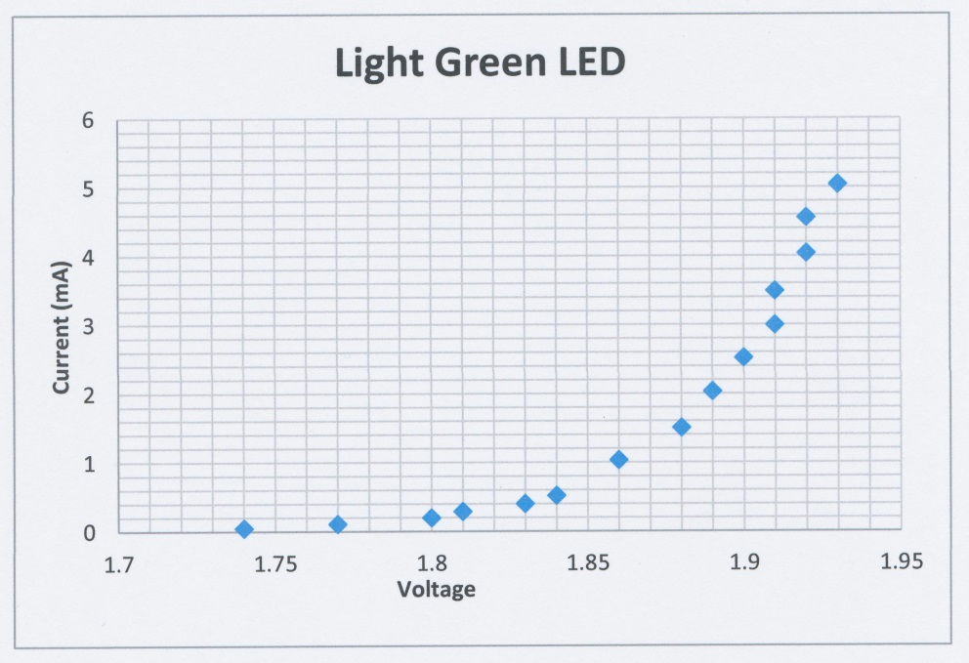

Va

(a) On each graph, find the straight line of 'best fit' to join up the points that slope up from the x-axis. If the points lie close to the line, a linear relationship holds between the applied voltage and the current in this region of the graph. [2]

(b) Determine the activation voltage (Va) from the collected data for each LED. It can be read from the graph by extrapolating a straight line through the current vs voltage graphs for each coloured LED where they intercept the x-axis. Show the value on the graph. [2]

1. Combine your data with the other students in the group and complete the following Table.

|  |  |  |  |  |
| --- | --- | --- | --- | --- |
| LED colour | Wavelength, λ  (nm) | Frequency, f  (Hz) | Activation voltage  (Va) | Ek of electrons  (W = V q)  (J) |
| infrared | 940 |  |  |  |
| red | 635 |  |  |  |
| yellow | 583 |  |  |  |
| green | 523 |  |  |  |
| blue | 473 |  |  |  |
| ultraviolet | 385 |  |  |  |

[4]

1. Graph kinetic energy (vertical axis) vs frequency (horizontal axis). [4]



1. Determine the slope of the graph, which is Planck's constant. [3]
2. How does your value compare with the accepted value for the Planck constant of

6.626 x 10-34 J s? [3]